**HANSBERRY, LORRAINE (1930-1965)**

Born in Chicago in 1930, Lorraine Hansberry made history when her play *A Raisin in the Sun* premiered on Broadway in 1959 as the first work by an African American woman to appear on the Great White Way. Realist in style, *A Raisin in the Sun* engaged with modern American drama’s investigation of the salience of the American Dream in the context of the Cold War, situating the deferred dreaming of the Younger family within a long history of foreclosed desire and possibility. Hansberry remains best-known for *A Raisin in the Sun*, but the play both exemplifies and overshadows her other accomplishments as a black lesbian artist-activist, only gesturing towards the expansive political vision of her work as a whole, including her exploration of slavery in *The Drinking Gourd* (1960), her treatment of apocalypse in *What Use Are Flowers* (1962), and her consideration of black freedom movements in *Les Blancs* (1964) and *The Movement: A Documentary of a Struggle for Equality* (1964)*.*

*A Raisin in the Sun* demonstrates Hansberry’s early and ongoing interest in black internationalism and coalition-formation across the diaspora. The niece of Africanist scholar Leon Hansberry, she moved to New York after a year of study at the University of Wisconsin and began a less conventional form of education, working for Paul Robeson’s magazine *Freedom* and covering, among other stories, the Kenyan independence movement. Her early work as a journalist informed the characterization of the African student Asagai in *A Raisin in the Sun*, but also shaped *Les Blancs*, one of her final plays. Bookended by *A Raisin in the Sun* and *Les Blancs*, Hansberry’s major artistic work reveals a feminist impulse to destabilize categories of race, gender, and sexuality and a persistent investigation of the possibilities and limitations of building black diasporic and interracial communities both locally and globally, a consideration foregrounded in her 1964 play *The Sign in Sidney Brustein’s Window*, which depicts the struggles of the eponymous protagonist to sustain his marriage and manage the competing desires of his Bohemian community.

*A Raisin in the Sun* and *Les Blancs* also demonstrate Hansberry’s recognition of the personal costs of enacting social change, her willingness to confront the impossibility of maintaining the status quo, and a resistance to mistaking winning a battle for winning the war against racial imperialism that produces ominous endings in both plays. Having survived the violence of desegregation when her own childhood home was vandalized, Hansberry knew well the costs of ‘moving up,’ and while *A Raisin in the Sun* ends with the Youngers moving to a white neighborhood that is ostensibly a better environment for the family, the play also reveals that other efforts to desegregate have been met with violence. Similarly, although *Les Blancs* ends with the fires of an independence movement burning in an imagined African country, the struggle for self-governance turns brother against brother, resulting in the death of one at the hands of the other. The struggle for community depicted in all of Hansberry’s work reflects a deep feeling of alienation emblematic of modernism, while at the same time her work maintains the necessity of that struggle.

**Major Works**

Hansberry, Lorraine. (1994) *Les Blancs: The Collected Last Plays*, New York: Vintage.

*A Raisin in the Sun* (1959).

*The Drinking Gourd* (1960).

*The Sign in Sidney Brustein’s Window* (1964).

*The Movement: Documentary of a Struggle for Equality* (1964).

*To Be Young, Gifted and Black: An Informal Autobiography of Lorraine Hansberry*  (adapted by Robert Nemiroff) (1970).

**References and Further Reading**

Carter, Steven R. (1991) *Hansberry’s Drama: Commitment and Complexity*, Urbana: University of Illinois Press.

Elam Jr., Harry J. (2001) ‘The Device of Race: An Introduction,’ *African American Performance and Theater History*, ed. Harry J. Elam Jr. and David Krasner, Oxford: Oxford University Press, 3-16.

Higashida, Cheryl. (2008) ‘To Be(come) Young, Gay, and Black: Lorraine Hansberry’s Existentialist Routes to Anticolonialism,’ *American Quarterly* 60.4 (December 2008): 899-924.

Wilkerson, Margaret B. ‘The Dark Vision of Lorraine Hansberry: Excerpts from a Literary

Biography,’ *Massachusetts Review* 28.4 (Winter 1987): 642-650.

Wilkerson, Margaret B. ‘The Sighted Eyes and Feeling Heart of Lorraine Hansberry,’ *Black*

*American Literature Forum* 17.1 (Spring 1983): 8-13.

**Soyica Colbert, Georgetown University**

**Recommended Illustrations**

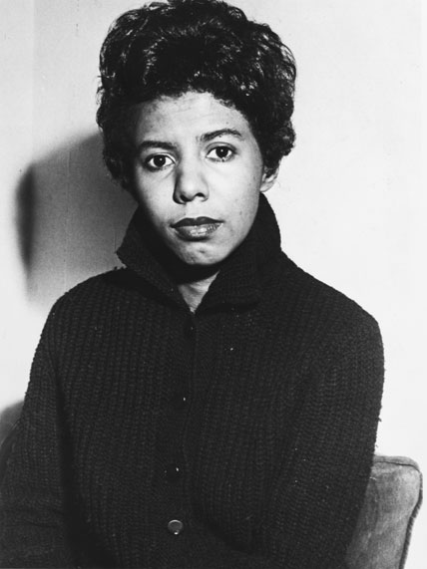

**Lorraine Hansberry**

[Available at New York Public Library digital Collections: http://digitalcollections.nypl.org/items/608ce970-d5e2-0130-9442-58d385a7b928]

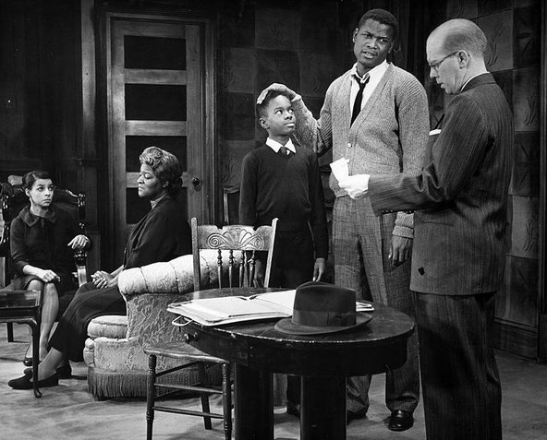

**Ruby Dee, Claudia McNeil, Glynn Turman, Sidney Poitier and John Fielder in the 1959 production of *A Raisin in the Sun*.**

[Available at: <http://en.wikipedia.org/wiki/File:A_Raisin_in_the_Sun_1959.JPG>

Also available at:

<http://learning.blogs.nytimes.com/2014/03/13/text-to-text-a-raisin-in-the-sun-and-discrimination-in-housing-against-nonwhites-persists-quietly/?_php=true&_type=blogs&_r=0>]

**Note: A similar image (below) is available through the NYPL, but the above image of the production is better, so please use it if possible:**

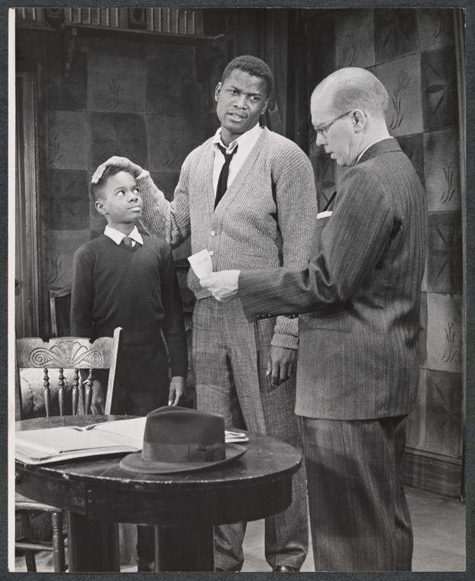

**Glynn Turman, Sidney Poitier, and John Fiedler in the 1959 production of *A Raisin in the Sun*.**

[Available through New York Public Library Digital Collections: http://digitalcollections.nypl.org/items/936c3860-d439-012f-6d8f-58d385a7bbd0]